Arkansas Department of Veterans Affairs
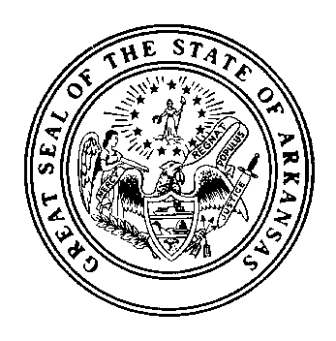

Administrative Offices
1501 W. Maryland Avenue
North Little Rock, AR 72120
Voice (501) 992-0306 / FAX (501) 992-0162

Mike Beebe Alicia (Cissy) Rucker
Governor Director

Arkansas State Veterans Cemetery
Columbarium Expansion Grant Narrative AR-10-04

On November 11, 2001, the Arkansas State Veterans Cemetery was formally dedicated to serve all honorably discharged veterans. The cemetery, situated on an 82-acre site, is located in North Little Rock at 1501 West Maryland Avenue. The Arkansas Department of Veterans Affairs operates the cemetery to commemorate the military service of our deceased veterans. Our cemetery system provides the visiting family and friends an atmosphere of peacefulness and dignity.

The cemetery currently has six columbariums that accommodate 800 interments. As of September 27, 2012 we have 112 available. The cemetery has a columbarium interment rate of 85 per year. At this rate, we will be full in an estimated 1.3 years. We are requesting to expand the columbariums by six. The estimated cost is $400,000.00.

In addition to the columbarium expansion, we are requesting 3,800 double depth crypt at $800 per crypt is $2,800,000.00. For 1,000 traditional burial sites, the estimated cost is $200 per interment area totaling $200,000.00. Therefore, the total estimated cost for the cemetery expansion project, including contingencies, is $3,506,850.00. This will allow for better expansion options and plan for our columbarium area in the future. Approval of this grant will enable the Arkansas State Veterans Cemetery to continue to meet the future needs of our veterans and their families.

