TSG Status Report # 1
Appendix

To: Arkansas Health Reform Task Force
Re: Health Care Reform/Medicaid Consulting Services
Da: June 11, 2015

PREPARED BY:
THE STEPHEN GROUP
814 Elm Street, Suite 309
Manchester, NH, 03102
Main: (603)419-9592
www.stephengroupinc.com

June 2015

Table of Contents
Initial Financial Assessment 3
Profile of Spending by Beneficiary Category 3
Profile of Spending by Type of Service 5
Spending by Beneficiary 7
Hospital Spending 8
Long Term Care Spending 9
Mental Health Spending 11
Pharmaceutical Spending 12
Private Option 12
Administration Expenses 13
Trends in Enrollees 14
Drivers of Future Spending 15
The Top 100 Utilizers 18
Top 100 Providers 19
Comparison to Other State Medicaid Program Spending 21
Distribution of Medicaid Spending on Acute Care 22
Distribution of State Medicaid Funding on Long Term Care 22
State Medicaid Spending per Enrollee (Full or Partial Benefit) 23
Distribution of Acute Care/Long Term Care/DSH Payments 23
Expenditures per Resident: Total LTSS Costs: FY 2012 25
Professional Services Contracts 26
Health Independence Account 36
DHS Previous Third Party Liability Cost Savings Initiatives 37
Traditional Medicaid: Ten Year History of Arkansas FMAP 38
Answers Provided by Blue Cross Blue Shield to TSG Questions Related to Private Option Address Concerns 39
DHS and DMS Organization 41

Initial Financial Assessment

Profile of Spending by Beneficiary Category
In SFY 2014, Medicaid expended $5.1 billion in claims and other benefits. The largest aid group is the SSI Disabled at 25% of total expenditures. The second and third largest are Low Income Children and Pregnant Mothers and Medically Needy Aged. The Private Option program was in place for only part of 2014; by 3Q2015, it had grown to 19% of total expenditures.
Medicaid has grown 54% over the period since 2007, from $3.3 billion to $5.1 billion. That is a Compounded Annual Growth Rate (CAGR) of 6.3%. The rate of growth has moderated significantly over the years since 2010. In 2010 the year-over-year growth was 10%, though in 2014 the growth in Traditional Medicaid had moderated to 2% year-over-year. The fastest growth segment of Medicaid was non-claims payments at 8.2% since 2010, 50% faster than the overall growth rate. In 2014, 15% of Medicaid was paid for expenditures other than claims ($983 million).
The five largest categories of beneficiaries account for 93% of traditional Medicaid spending:
- SSI Disabled
- Low Income Children & Pregnant Women
- Medically Needy Aged
- Medically Needy Disabled
- Non Claims Based Payments
Note that Non-Claims payments account for 21% of expenditures and are not actually paid directly on behalf of beneficiaries, but to help reimburse providers for costs—without specific claims. Non-claims-based payments are the largest growth category, at 5.7% year on year growth in 2014. The four largest segments in the list above are actual beneficiaries, and account for 71% of spending.
While growth rates in total Traditional Medicaid have fallen since 2008 (Figure 2), several beneficiary categories have experienced especially noteworthy declines:
- SSI Aged and Medically Needy have decreased throughout the period, with a negative growth rate in 2008 through 2014
- Spenddown Disabled and Spend down Families and TANF switched from positive to negative growth since 2010
Table 1 Medicaid Spending by Beneficiary Aid Category, 2007-2014
Figure 1 Components of Medicaid Expenditures by Beneficiary Aid Category, 2014. Includes Private Option
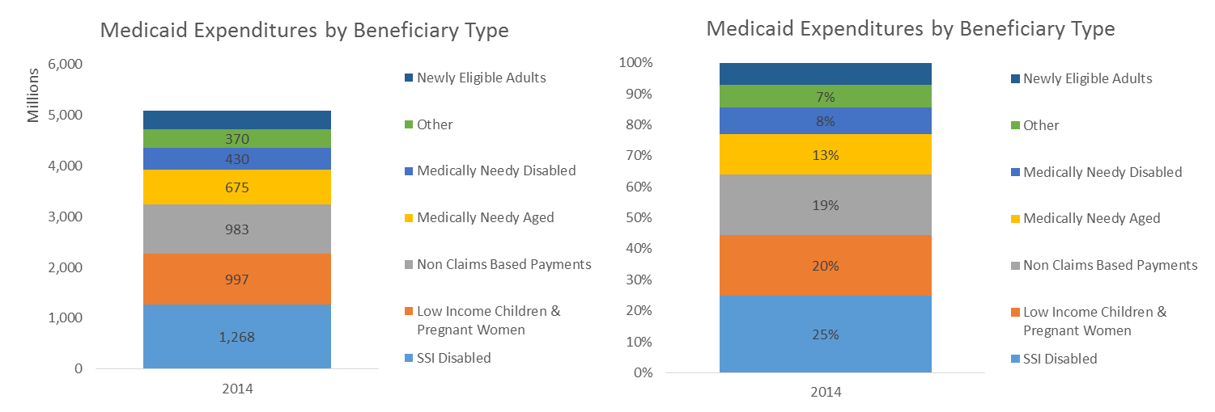
Table 2 Growth Rates for Beneficiary Aid Categories
Table 3 Year over Year Growth Rates by Beneficiary Aid Category, 2008-2014
Figure 2 Year over Year Growth Rates by Beneficiary Aid Category, 2008-2014
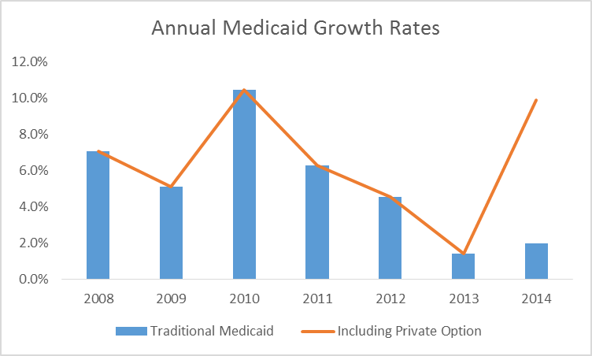
Figure 3 Growth Rate Changes from 2008-2014 Comparing Three Aid Categories with Total
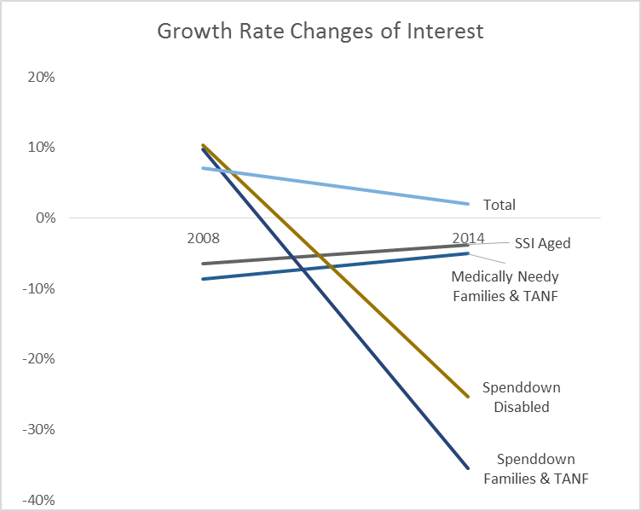

Profile of Spending by Type of Service
Hospital Services is the largest component of Arkansas Medicaid, comprising $1.2 billion (31.7% of total) in 2014. It is also the fastest growing cost segment, with a CAGR since 2010 of 4.9% compared to Total Traditional Medicaid of 3.5%. Developmental Disability (DD) and Mental Health have also been growing faster the 3.5% total annual growth rate, while Long Term Care (LTC), Prescription Drug and Physician Services have grown below that rate. Care costs (besides Private Option premiums) grew at a resurgent rate largely owning to Fee For Services (FFS) costs from Medically Frail, a Private Option population.
Table 4 Traditional Medicaid Spending by Cost Category, 2007-2015
Figure 4 Medicaid Expenditures by Cost Category, Total and Percent. Traditional Medicaid Only
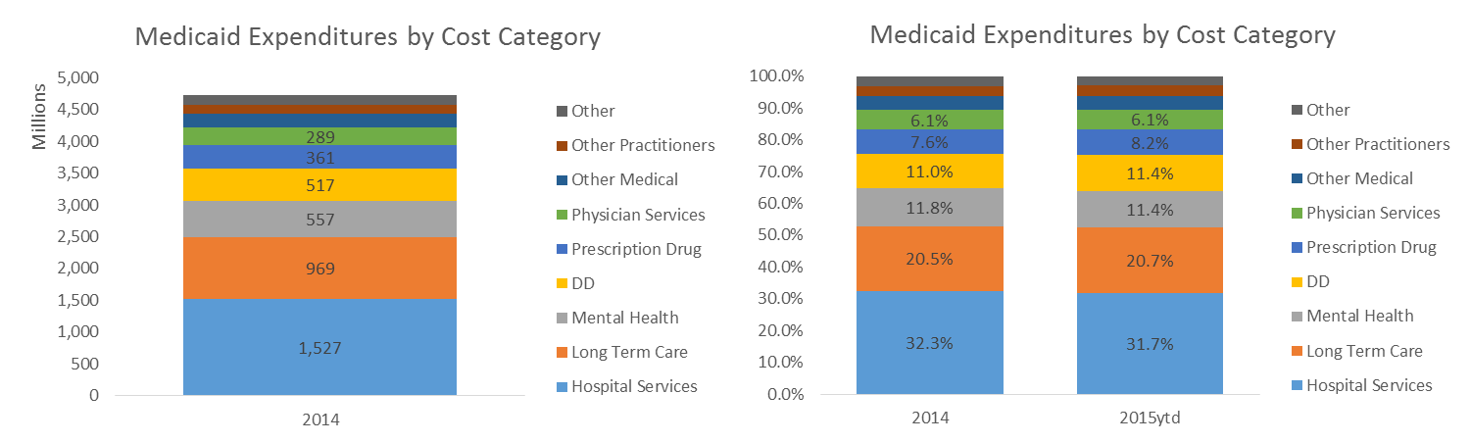
Table 5 Growth Rates by Cost Category. Traditional Medicaid Only
Table 6 Year over Year Growth Rates by Cost Category, 2008-2014. Traditional Medicaid Only
Table 7 Cost Category as a Percent of Traditional Medicaid, 2007-2015ytd
The following table shows the distribution of costs by Aid Category. Note that the largest Beneficiary group is SSI Disabled, which incurs claims spread across Hospital, LTC, Mental Health, DD and Prescriptions. Low Income Children and Pregnant Women incur largely Hospital Services and Mental Health. Not surprisingly, most of the Medically Needy Aged costs are with LTC (and most of that is Nursing Homes). The Medically Needy Disabled incur costs in LTC and DD.
Deserving further consideration are the following observations:
- Low level of Prescription Drugs for the Medically Needy Aged
- What is the $46 million in non-claims based prescriptions?
- What “other practitioners” are the Low Income Children and Pregnant Women seeing so frequently ($87 million)
- Where are the 100 large-claims-amount beneficiaries—are they in Medically Needy Disabled? That is not a big category
Table 8 Traditional Medicaid Expenditures by Cost Category and Beneficiary Aid Category, 2014

Spending by Beneficiary
The amount spent per beneficiary is obviously affected by increasing expenditures with flat enrollment. The table below estimates claims expenditure per beneficiary per month (e.g. PMPM). This is merely a first estimate, and must be further investigated.
Table 9 Medicaid Spending PMPM

Hospital Spending
Hospital spending is the largest category of cost, 32% of Traditional Medicaid. The most troubling aspect of hospital services in our initial data review is the large share that is paid outside the claims process. This shifts reimbursement from the rational, contractual or policy-based method of reimbursement to an ad hoc basis that can be driven outside of consistent policy. This subjects Medicaid to pressures other than providing high-quality healthcare. TSG has no indication of any impropriety, only the need to be able to explain to the Task Force what forces are driving this 20% of total Medicaid costs.
Initial observation reveals that of the half of hospital costs that are tied to claims, two thirds are for inpatient services. This seems to be at odds with the long-time, national trend toward more outpatient services. It may suggest a fundamental issue with the manner through which Traditional Medicaid services are provided—more through high-cost, inpatient services.
Table 10 Hospital Services Costs, 2007-2015ytd

Long Term Care Spending
LTC accounts for 20.2% of Traditional Medicaid in 2014. Arkansas spends most (over 70%) of its LTC on nursing homes. TSG learned that the state is limits Assisted Living beds to no more than 1,000. As of March 2015 there were only 771 patients being served in Assisted Living facilities. Likewise, Home and Community-based services account for only 25% of LTC.
Table 11 Long Term Care Expenditures, 2007-2014
By far, the largest sub-segment of LTC is Nursing Homes for the Medically Needy Aged—$457 million or 47% of total LTC.
Table 12Long Term Care Details of Expenditure by Aid Category, 2014

Mental Health Spending
Mental Health accounts for 19% of total Medicaid (including Private Option). Arkansas has added a number of new service categories to Mental Health since 2007, especially in 2010. Still, in 2014 over half of the category is in two areas: Community Mental Health (RSPMI) and Inpatient Psychiatric. The fastest-growing sub-category is Rehab Services School Based CHMS, which was started in 2012 and has grown to $7.3 million. Notwithstanding the added sub-categories of care, Mental Health has still grown at just over the overall Medicaid pace, 4.3% CAGR since 2010 and 2.1% 2014 over 2013. Of that, Community Mental Health has grown the most, nearly 1/3 since 2007.
Table 13 Mental Health Details of Expenditure, 2007-2015ytd
Nearly half (43%) of Mental Health care is in 2 subcategories: Community Mental Health for Low Income Children and Pregnant Women and SSI Disabled. Fully 81% is provided to the two Beneficiary Categories: Low Income Children and Pregnant Women and SSI Disabled.
Table 14 Mental Health Detail Expenditures by Beneficiary Aid Category, 2014

Pharmaceutical Spending
Pharmacy spending is dominated by a single sub-category, Prescription Services. TSG will investigate this is significantly greater detail using forthcoming claims data. All other subcategories are small in not growing.
Table 15 Prescription Drug Spending Details, 2007-2015ytd
By subcategory, Medicaid spends 68% on Prescription Services for SSI Disabled and Low Income Children and Pregnant Women.
Table 16 Prescription Drug Expenditures by Beneficiary Aid Category, 2014

Private Option
Private Option began in 2Q2014. It includes two categories of beneficiaries: Medically Frail and those receiving discounted capitated coverage through one of the “metals” programs.
Table 17 Private Option Expenditures by Quarter, 2014-2015

Capitated Private Option
Three private insurance carriers provide capitated coverage for a portion of the Private Option beneficiaries. TSG is still working to break apart the capitated and FFS enrollees. Costs are as above.

Medically Frail
On a cost basis, the Medically Frail component of Private Option is $86 million in 2014 and on track for nearly $250K in SFY 2015. Thus, it is running about 17% of total Private Option. TSG will have more information on how to break out Medically Frail from capitated coverage for the next update.

Administration Expenses
Administration costs $24 million in 2014. This amount is shared 50/50 with CMS.
Table 18 Administration Expenditures, 2014
TSG will report more about administration costs in the next update.

Trends in Enrollees
Table 19 Enrollees in Traditional Medicaid and Private Option by Beneficiary Aid Category, 2006-2015, as of March each year
The trend in enrollees is flat for 2015 compared to either 2006 or 2010 (0.3% and -0.3% respectively). Thus, while the population has been growing at 0.5%, the number of Traditional Medicaid enrollees has not increased. This, however, masks a shift in enrollees. The high-growth areas have not primarily been the aged, rather the medically needed and low income:
- Medically Needy Families & TANF
- Adoption and Foster Care
- Medically Needy Disabled
- Low Income Children & Pregnant Women
- Medically Needy Aged

Services to SSI Aged (as well as ARKids and SSI Disabled) are down significantly since 2010:
Table 20 Enrollment Growth Rates
Reviewing year over year growth rates since 2007 in the table below suggests some important observations about enrollment:
- Except for 2010, growth has been approximately the same as the overall population, 0.5% per year
- Decrease in 2014 suggests a measure of the transfer of beneficiaries from Traditional Medicaid to Private Option
- The expected outcome was that Pregnant Women would shift from Traditional Medicaid to Private Option However, instead the Aid category Low Income Children and Pregnant Women grew by 9.9% in 2014
- Medically Needy Families and TANF grew significantly in 2014, following years of decline
- Adoption and Foster Care has increased at a much larger rate over the years 2014 and 2015 compared to history
- Spenddown is disappearing, presumably those beneficiaries are moving to Private Option
Table 21 Year over Year Enrollment Growth Rates 2007-2015

Drivers of Future Spending
Three key drivers could explain changes in Medicaid expenditure: population, provider cost or health coverage. Population accounts for little of Arkansas’ Medicaid growth, as population has grown at a CAGR of 0.4% since 2010.
Table 22 Historical Population of Arkansas compared to US
Arkansas’ population demographics are similar to those of the rest of the US on several key dimensions that could drive differences in healthcare: ethnicity, education, foreign birth and age. On the dimension of disabilities, Arkansas has a somewhat higher rate than the US. Thus, aging of the population will drive caseload and budget growth disproportionately in the direction of aging services. In addition, Arkansas will likely see its already-high rate of disabilities to continue due to these demographic shifts.
Arkansas’ population has roughly the same age distribution as the US, with about 1% more over-65 and 1% more under 18 years of age.
Table 23 US and Arkansas Population Historic Growth by Age
Forecasts are that the Arkansas’ elder population will grow faster than the rest of the demographic.
Figure 5 US and Arkansas Population Projected Growth by Age
Thus, the over-65 portion of the population will likely grow from 21% to 24% over the next 5 years. It is likely that each of the categories of aged services could increase at a slightly higher rate. Increasing at a rate 0.35% faster than population growth would be consistent with shifting the aged population from 21%-24% between 2012 and 2020.
Table 24 Arkansas Project Population Percentages by Age
Arkansas’ population has higher rate of disabilities than the US average, 16.8% compared to 12.1%. This difference is consistent across age demographic. Note that growth in the categories of beneficiary already indicate higher growth for DD as well as a higher share than the rest of the US. Accordingly, it seems conservative to forecast DD at the same rate of historic growth.
Table 25 Arkansas and US Disability Populations by Age
The ethnicity of Arkansas’ population resembles that of the US in most categories, with slightly more Whites and Black and fewer Asians and Hispanics.
Table 26 Arkansas and US Population by Percentage Ethnic Group
Arkansans have a higher rate of High School graduation, and lower levels of post-secondary education.
Table 27 Arkansas and US Population by Educational Achievement
Arkansas’ population includes fewer residents not born in the US (4.6% vs. 13.2%). Of those, a higher portion are not US citizens (70.3% vs. 54.9%).
Table 28 Arkansas and US Population by Percent Foreign-born

The Top 100 Utilizers
Table 29 List of the Top 100 Most Costly Traditional Medicaid Beneficiaries
Ranking | Paid Amount
1 | $5,986,250.95
2 | $1,803,520.54
3 | $1,611,679.32
4 | $1,509,065.76
5 | $1,438,493.57
6 | $1,397,421.29
7 | $1,366,608.48
8 | $1,319,506.95
9 | $1,289,086.79
10 | $1,217,980.47
11 | $1,210,710.48
12 | $1,207,919.99
13 | $1,203,597.31
14 | $1,165,083.22
15 | $1,150,274.85
16 | $1,121,937.74
17 | $1,089,139.79
18 | $1,073,175.63
19 | $1,015,628.57
20 | $1,004,087.90
21 | $983,959.51
22 | $946,802.44
23 | $885,818.63
24 | $881,694.10
25 | $870,505.95
26 | $867,785.64
27 | $864,028.72
28 | $862,574.85
29 | $839,848.32
30 | $839,493.93
31 | $819,778.49
32 | $812,529.11
33 | $777,951.10
34 | $766,837.97
35 | $766,490.99
36 | $766,467.67
37 | $751,702.52
38 | $710,572.72
39 | $708,320.60
40 | $691,269.72
41 | $687,049.68
42 | $685,318.43
43 | $671,222.20
44 | $665,267.23
45 | $663,715.72
46 | $663,334.61
47 | $657,143.09
48 | $655,646.12
49 | $648,042.60
50 | $647,181.76
51 | $646,521.82
52 | $630,532.50
53 | $629,726.73
54 | $617,030.69
55 | $596,519.87
56 | $591,823.85
57 | $589,062.92
58 | $585,419.31
59 | $582,001.85
60 | $579,281.93
61 | $577,231.11
62 | $576,934.41
63 | $576,016.07
64 | $570,928.94
65 | $566,437.22
66 | $564,047.00
67 | $561,591.84
68 | $557,468.69
69 | $554,062.74
70 | $551,129.77
71 | $549,834.48
72 | $546,075.64
73 | $545,623.59
74 | $543,390.78
75 | $543,221.05
76 | $542,984.34
77 | $541,886.39
78 | $539,921.30
79 | $539,108.45
80 | $536,611.09
81 | $532,210.10
82 | $532,113.18
83 | $530,983.68
84 | $526,803.58
85 | $522,187.26
86 | $521,271.56
87 | $521,053.01
88 | $519,298.35
89 | $517,368.04
90 | $511,442.21
91 | $503,411.88
92 | $494,992.61
93 | $488,991.26
94 | $482,922.50
95 | $479,851.87
96 | $478,844.75
97 | $478,061.25
98 | $474,982.33
99 | $474,113.05
100 | $473,237.35

Note: High utilizers included Medically Fragile under Private Option that are on the Traditional Medicaid program per CMS Waiver.
According to Dr. William Golden, Professor of Medicine and Public Health and UAMS, there were 30 hemophilia cases, a few burns, a few severe trauma, a few neonatal prolonged stays, some cystic fibrosis and severe mental illness with hospitalizations. In addition, many on the list have pharmacy cost as a predominant component of their expenses.
TSG is working with DHS to drill down on costs per category of beneficiary as well as diagnosis and treatment modality to get more instructive data here.

Top 100 Providers

Table 30 List of the Top 100 Most Costly Traditional Medicaid Beneficiaries
Provider Name | Paid Amount
Arkansas Childrens Hospital | $267,649,061.48
Univ Hospitalof Arkansas | $129,959,313.20
Conway Human Development Center | $97,343,450.76
Arkansas Health Center | $57,046,407.96
Baptist Medical Center | $44,648,321.25
Independent Choices | $33,687,125.01
Medical Collegephysicians Group | $31,256,215.73
First Step Inc | $30,628,521.84
Childrens University Med Group | $30,486,555.53
Bost Inc | $28,682,251.27
St Bernards Regional Med Center | $28,567,696.72
Arkansas Dept Of Health And Human | $27,396,371.19
St Vincent Infirmary Medical Ctr | $25,625,211.70
Booneville Human Development Ctr | $25,174,627.90
Arkadelphia Human Dev Center | $24,188,503.29
United Cerebral Palsy Of Central | $21,767,713.32
Fort Smith Hma Llc | $21,533,227.55
Independent Case Management Inc | $20,865,659.17
Jonesboro Human Development Ctr | $20,426,677.42
Mercy Hospital Fort Smith | $20,335,610.72
Southeast Arkansas Human Dev Ctr | $20,001,741.79
Ozark Guidance Center Inc | $19,775,244.96
White County Medical Center | $19,460,769.45
Friendship Community Care Inc | $19,306,092.55
Caremark Tennessee Specialty Pharm | $19,133,432.70
Millcreek Of Arkansas | $19,039,037.50
BHC Pinnacle Pointe Hospital Inc | $18,705,657.74
Methodist Hospitals Of Memphis | $18,173,576.82
Jefferson Regional Medical Center | $16,721,269.80
Arkansas Support Network | $16,434,208.37
Mercy Hospital Hot Springs | $16,389,018.80
White River Medical Center | $14,950,020.72
Washington Regional Medical Ctr | $14,320,101.76
Piney Ridge Treatment Center | $14,240,450.00
Pathfinder Inc | $13,761,921.86
Ach Physicians Services | $13,326,260.27
Northwest Medical Center | $12,916,123.76
Community Counseling Services Inc | $12,621,352.39
Superior Senior Care Inc | $12,582,222.18
Mercy Hospital Rogers L | $12,456,674.95
Full Potential Child Development | $12,154,303.16
Integrity Inc | $11,743,887.88
Abilities Unlimited Jonesboro Inc | $11,544,843.98
Baptist Healthmed Ctr Nlr | $11,533,139.32
Youth Home Inc | $11,529,350.00
Southeastrans Inc | $11,073,833.90
Vantage Point Of Northwestarkans | $10,983,730.15
Southeastrans Inc | $10,604,123.50
United Methodist Behavioral | $10,501,257.74
Ar Dept Of Health Home Health | $10,401,201.47
Christus St Michael Health System | $10,310,361.98
AR State Hospital | $10,290,137.05
The Arkansas Hospice | $10,273,948.97
St Marys Regional Medical Center | $9,836,342.02
UHS Of Benton Inc | $9,764,402.55
LeFleur Transportation Of Texas | $9,537,261.26
Conway Regional Medical Ctr Inc | $9,524,361.44
Trinity Behavioral Health | $9,458,750.00
Support Solutions Of Arkansas Llc | $9,372,624.44
Baxter County Regional Hospital | $9,261,025.83
Arkansas Pediatric Facility | $9,239,429.30
Total Life Healthcare Inc | $9,168,280.53
United Medical | $9,113,065.57
Searcy Health And Rehab Llc | $8,885,930.63
Brownwood Lifecare Center | $8,884,121.05
Rainbow Of Challenges Inc | $8,864,953.88
NW Med Ctr Willow Creek Women Hos | $8,785,975.58
Southwest Arkansas Counseling And | $8,735,438.19
Network Of Community Options Inc | $8,706,937.18
Millcreek Of Arkansas | $8,702,866.27
Davis Life Care Center | $8,454,977.25
First Step Inc | $8,378,011.17
Families Inc Of Arkansas | $8,331,879.73
Area Agency On Aging Of Western | $8,324,042.09
White River Area Agency On Aging | $8,315,817.58
Easter Seals Arkansas | $8,315,437.64
Life Strategies Of Arkansas Llc | $8,294,892.26
Perspectives Behavioral Health Ma | $8,172,722.23
Magnolia Health And Rehab Llc | $8,145,247.36
AR Childrens Hospital Pharmacy | $8,048,753.68
National Park Medical Center | $8,046,739.43
Lakeland Behavioral Health System | $8,042,892.31
Centers For Youth & Families Inc | $8,002,397.12
Arkansas Enterprises For The Deve | $7,845,275.13
Counseling Associates Inc | $7,843,595.77
Valley Behavioral Health System | $7,725,563.67
Saline Memorial Hospital | $7,713,274.03
Easter Seal Arkansas | $7,694,257.17
Area Agency On Aging Of Western | $7,679,450.70
North Arkansas Regional Medical | $7,646,358.53
Valley Behavioral Health System O | $7,581,655.96
Woodridge Behavioral Care Of | $7,570,979.00
Wadley Regional Medical Center | $7,537,167.98
Greene Acres Nursing Home | $7,501,933.20
Anr 1 Llc | $7,414,629.82
Central Arkansas Radiation Therapy | $7,393,636.03
Mid South Health Systems Inc | $7,369,908.36
Youth Villages Inc | $7,343,411.00
Independent Living Services Inc | $7,330,612.79
Absolute Care Management Corp | $7,316,935.08

Comparison to Other State Medicaid Program Spending

All States’ Distribution of Medicaid Spending on Acute Care
State | Inpatient | Physician Lab/X-Ray | Outpatient | Prescribed Drugs & Other Services | Payments to Medicare | Payments to Managed Care Plans | Total
US | $59,204B | $13,225B | $27,323B | $48,062B | $14,795B | $136,230B | $298,840B
Arkansas | 699,684M | 333,147M | 342,406M | 1,019B | 295,856M | 13,168M | 2,703B
Kansas | 239,771M | 49,056M | 49,728M | 83,268M | 82,869M | 1,358B | 1,863B
Louisiana | 1,232B | 370,221M | 423,821M | 607,269M | 264,739M | 1,301B | 4,199B
Mississippi | 1,206B | 226,678M | 324,689M | 530,538M | 203,536M | 607,272M | 3,099B
Missouri | 1,921B | 68,072M | 1,051B | 1,495B | 317,508M | 1,109B | 5,962B
Oklahoma | 1,221B | 571,452M | 671,367M | 713,482M | 132,788M | 187,487M | 3,497B
Tennessee | 1,070B | 27,046M | 63,090M | 684,246M | 340,318M | 5,467B | 7,652B
Texas | 4,292B | 1,234B | 555,502M | 3,403B | 1,025B | 12,008B | 22,518B
Source: Kaiser Family Services: State Health Facts: FY 2013
Note: As part of this project, TSG will be reaching out independently to states and may obtain more updated data, including financial data within the State of Arkansas Medicaid so the use of Kaiser is only to provide the Task Force with some snapshot of comparison without knowing exactly the data sets that Kaiser Family Services used for their State Health Facts report.

Distribution of State Medicaid Funding on Long Term Care
State | Nursing Facilities | ICF/ID | MH Facilities | Home Health–Personal Care | Total
US | $50,769B | $12,184B | $3,575B | $56,488B | $123,016B
Arkansas | 641,411M | 163,192M | 159,938M | 478,426M | 1,443B
Kansas | 143,376M | 55,240M | 18,658M | 421,568M | 638,842M
Louisiana | 921,042M | 415,213M | 2,384M | 842,511M | 2,181B
Mississippi | 768,640M | 260,372M | 74,201M | 296,027M | 1,419B
Missouri | 983,067M | 106,059M | 23,130M | 1,174B | 2,286B
Oklahoma | 561,789M | 111,612M | 72,238M | 511,275M | 1,257B
Tennessee | NA/MC | 294,247M | 33,892M | 699,910M | 984,125M
Texas | 2,360B | 1,064B | 20,841M | 2,150B | 5,594B
Source: Kaiser Family Foundation: State Health Facts: FY 2013
Note: As part of this project, TSG will be reaching out independently to states and may obtain more updated data, including financial data within the State of Arkansas Medicaid so the use of Kaiser is only to provide the Task Force with some snapshot of comparison without knowing exactly the data sets that Kaiser Family Services used for their State Health Facts report.

State Medicaid Spending per Enrollee (Full or Partial Benefit)
State | Aged | Individuals with Disabilities | Adults | Children | Total
US | $13,249 | $16,643 | $3,247 | $2,463 | $5,790
Arkansas | 12,994 | 11,564 | 1,638 | 2,420 | 5,264
Kansas | 13,643 | 14,829 | 3,745 | 2,212 | 5,996
Louisiana | 9,607 | 10,769 | 5,000 | 2,913 | 5,937
Mississippi | 10,347 | 10,450 | 4,084 | 2,430 | 5,335
Missouri | 14,706 | 16,401 | 3,005 | 2,978 | 6,488
Oklahoma | 10,085 | 13,820 | 2,973 | 2,462 | 4,782
Tennessee | 8,595 | 11,679 | 4,731 | 2,467 | 5,155
Texas | 9,751 | 15,259 | 3,263 | 3,016 | 5,278
Source: Kaiser Family Foundation: State Health Facts: FY 11
Note: As part of this project, TSG will be reaching out independently to states and may obtain more updated data, including financial data within the State of Arkansas Medicaid so the use of Kaiser is only to provide the Task Force with some snapshot of comparison without knowing exactly the data sets that Kaiser Family Services used for their State Health Facts report.

Distribution of Acute Care/Long Term Care/DSH Payments
State | Acute Care | Long Term Care | DSH Payments | Total
US | 68.2% | 28.4% | 3.7% | 100%
Arkansas | 64.2% | 34.3% | 1.5% | 100%
Kansas | 72.2% | 24.8% | 3.7% | 100%
Louisiana | 58.7% | 30.5% | 10.7% | 100%
Mississippi | 65.4% | 30% | 4.6% | 100%
Missouri | 66.6% | 25.5% | 7.9% | 100%
Oklahoma | 72.9% | 26.2% | .9% | 100%
Tennessee | 87.8% | 11.3% | .8% | 100%
Texas | 79.5% | 19.7% | .8% | 100%
Source: Kaiser Family Foundation/State Health Facts/FY2013
Note: As part of this project, TSG will be reaching out independently to states and may obtain more updated data, including financial data within the State of Arkansas Medicaid so the use of Kaiser is only to provide the Task Force with some snapshot of comparison without knowing exactly the data sets that Kaiser Family Services used for their State Health Facts report.

HCBS Spending as a Percent of Total LTSS
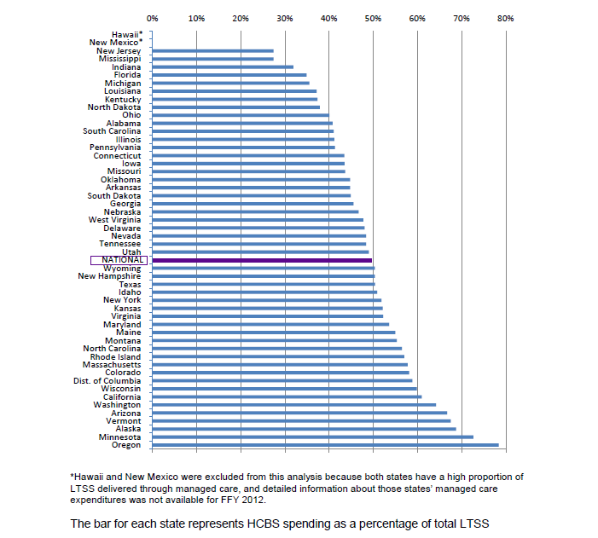
Source: Medicaid Expenditures for Long term Services and Supports in FY 2012: CMS/Truven Health Analytics; 4/29/14; p. 6 (FY 2013 data may be available prior to 10/14 and will be adjusted in the TSG Final Report)
Note: As part of this project, TSG will be reaching out independently to states and may obtain more updated data, including financial data within the State of Arkansas Medicaid so the use of Truven’s data analysis is only to provide the Task Force with some snapshot of comparison without knowing exactly the data sets that Truven used for their report.

Expenditures per Resident: Total LTSS Costs: FY 2012
State | Expenses Per Resident | State Rank
Arkansas | $606.64 | 11
Mississippi | 505.92 | 18
Louisiana | 488.72 | 19
Missouri | 454.56 | 23
Kansas | 415.29 | 27
Tennessee | 360.82 | 32
Oklahoma | 322.92 | 37
Texas | 291.09 | 42
US | $445.92 | NA
(Source: CMS/Truven Health Analytics: 4/28/14)
Note: As part of this project, TSG will be reaching out independently to states and may obtain more updated data, including financial data within the State of Arkansas Medicaid so the use of Truven’s data analysis is only to provide the Task Force with some snapshot of comparison without knowing exactly the data sets that Truven used for their report.

Professional Services Contracts
Contractor  Name | Summary | 2016  Contract  Amount | TOTAL  CONTRACT  AMOUNT | PROC  END  DATE | Procurement  Method | Contract  Service  Type | Direct or Indirect Operations (Y or N) *
Arkansas Chapter of the American Academy of Pediatrics (AAP) | Support PCMH Pediatrics | 188,470 | 188,470 | 6/30/2016 | Sole Source Contracts | Professional | N
Arkansas Foundation for Medical Care (AFMC) | Electronic health Record meaningful Use | 4,431,722 | 4,431,722 | 6/30/2016 | Sole Source Contracts | Professional | Y
AFMC | Child Health Management Services (CHMS) | 814,182 | 5,395,030 | 6/30/2017 | RFP amendments to extend | Professional | Y
AFMC | Medicaid Provider Representative | 2,064,512 | 10,139,885 | 6/30/2017 | RFP amendments to extend | Professional | Y
AFMC | PCMH Practice Transformation for APII | 1,300,000 | 1,300,000 | 6/30/2021 | RFQ amendments to extend | Professional | Y
AFMC | Retrospective Reviews of physical, speech, and occupational therapies and PA's for personal care for under age 21 | 1,151,844 | 8,062,908 | 6/30/2022 | RFP amendments to extend | Professional | Y
AFMC | To develop, review, implement & update criteria for utilization for PA's and extensions of benefits | 6,524,687 | 39,240,137 | 6/30/2018 | RFP amendments to extend | Professional | Y
AFMC | AR Innovative Performance Program (AIPP) for Long Term Care facilities | 1,545,508 | 10,469,618 | 6/30/2016 | RFP amendments to extend | Professional | N
AFMC | Medicaid Beneficiary Relations and Non Emergency Transportation (NET) Administration | 4,023,577 | 16,200,925 | 6/30/2017 | RFP amendments to extend | Professional | Y
AFMC | Child Health Management Services (CHMS) - REVIEW and Analytics Developmental Day Treatment Clinic Services (DDTCS) | 703,062 | 703,062 | 6/30/2016 | Sole Source Contracts | Professional | N
AFMC | Medicaid Quality Improvement | 2,729,382 | 12,000,000 | 6/30/2017 | RFP amendments to extend | Professional | Y
AR Dept of Health | Medicaid Outreach & Education ConnectCare and provide information in the Primary Care Case Management (PCCM) program & support ARKids 1st info line | 2,862,302 | 6,000,000 | 6/30/2017 | Intergovernmental | Professional | Y
AR Healthcare Foundation | Training in nursing homes to reduce antipschotic drugs | 200,000 | 200,000 | 8/30/2015 | Sub-Grant |  | Y
AR Healthcare Foundation | NH Administrator-in-Training Program | 58,573 | 58,573 | 6/30/2016 | Sole Source Contracts | Professional | Y
AR Medical Society | AR Health Care Payment Improvement Initiative Provider Outreach Specialist Position | 134,330 | 134,330 | 6/30/2016 | Sole Source Contracts | Professional | N
AR Medical Society | Medicaid PEER Review Committee | 21,120 | 21,120 | 6/30/2016 | Sole Source Contracts | Professional | N
AR Optometric Association | Medicaid Vision Consultation | 26,000 | 26,000 | 6/30/2016 | Sole Source Contracts | Professional | Y
AR State Dental Association | Medicaid Dental Consultation | 150,000 | 150,000 | 6/30/2016 | Sole Source Contracts | Professional | Y
Ar Optometric Association | Visual consultation for Arkansas Medicaid visual program & the ARKids program | 26,000 | 26,000 | 6/30/2016 | Sole Source Contracts | Professional | N
Bell, Stanley M "Jack" | Medicaid Admin. Hearing Officer | 16,850 | N/A | 6/30/2015 | RFQ's Legal/Other | Purchase Order | N
Bock Association  /Emeritus | LTC Pre-Admission Screening Assessments | 707,400 | 3,825,570 | 6/30/2018 | RFP amendments to extend | Professional | Y
Cognosante | ICD-10 Federal Mandate | 1,511,801 | 1,511,801 | 6/30/2016 | Sole Source Contracts | Professional | Y
Cognosante, LLC | DHS IT Project Management Office | 9,642,211 | 9,642,211 | 6/30/2016 | Sole Source Contracts | Professional | N
Cognosante, LLC | Independent Verification & Validation | 1,980,193 | 1,980,193 | 6/30/2016 | Sole Source Contracts | Professional | N
Cognosante, LLC | MMIS PMO | 5,395,727.04 | 18,134,893.00 | 6/30/2017 | RFP amendments to extend | Professional | N
Communications Group | ARKids First Media Campaign | 125,000.00 | 875,000.00 | 6/30/2016 | RFP amendments to extend | Professional | Y
Community Care Of North Carolina | Care coordination to Patient Centered Medical Homes (PCMH) | 360,000.00 | 2,450,000.00 | 6/30/2021 | RFQ | Professional | Y
Datapath | Private Option Health Care Independence Accounts | 8,200,000.00 | 8,200,000.00 | 6/30/2016 | Sole Source Contracts | Professional | Y
GDIT | Analytical Episode | 4,330,000.00 | 30,000,000.00 | 6/30/2021 | RFP amendments to extend | Professional | Y
Green Dental Laboratory | Adult Dentures | 1,835,388.00 | N/A | 7/31/2016 | IFB - Amendment to Extend | Technical | Y
Hause Actuarial Solutions | Actuary Services | 52,500.00 | 210,000.00 | 6/30/2018 | IFB - Amendment to Extend | Technical | N
Health Information Designs | Retrospective Drug Utilization Review | 263,455.00 | 1,822,070.00 | 6/30/2020 | RFP amendments to extend | Professional | Y
Health Management Systems, Inc. | Third Party Liability & Recovery Services (TPL) | 4,707,380.00 | 29,171,660.00 | 6/30/2017 | RFP amendments to extend | Professional | Y
Health Services Advisory Group, Inc. | Medicaid Data Mining and Program Evaluation | 896,764.00 | 5,606,984.00 | 6/30/2017 | RFP amendments to extend | Professional | N
HP Enterprise Services, LLC | MMIS Fiscal Agent | 57,106,070.00 | 200,000,000.00 | 6/30/2020 | Sole Source Contracts | Professional | N
HP Enterprise Medicaid Management Information System (MMIS) | MMIS Core | 27,708,092.06 | 27,708,092.06 | 11/30/2021 | RFP amendments to extend | Professional | N
James, Robert T. | Medicaid Admin. Hearing Officer | 16,850.00 | N/A | 9/30/2015 | RFQ's Legal/Other | PO | N
Jewel H. Harper | Medicaid Admin. Hearing Officer | 16,850.00 | N/A | 9/30/2015 | RFQ's Legal/Other | PO | N
Manatt, Phelps & Phillips LLP | Health Law and Policy Development | 1,305,000.00 | 1,305,000.00 | 6/30/2015 | Sole Source Contracts | Professional | N
Mckinsey and Company Washington | AR Health Care Payment Improvement Initiative | 15,400,000.00 | 15,400,000.00 | 6/30/2016 | Sole Source Contracts | Professional | N
Magellan | MMIS Pharmacy | 7,497,588.00 | 43,325,000.00 | 6/30/2020 | RFP amendments to extend | Professional | Y
Myers and Stauffer, LC (PHBV Partners) | Disproportionate Share Hospital Audit (DSH) | 46,730.00 | 347,940.00 | 6/30/2016 | RFP amendments to extend | Professional | N
Myers and Stauffer, LC (PHBV Partners) | Acuity Based Long-Term Care Reimbursement | 291,200.00 | 291,200.00 | 6/30/2015 | Sole Source Contracts | Technical | N
NET 1 - Lefleur Transportation of Texas, Inc. | Non-Emergency Transportation/Region- 1 | 3,986,235.27 | N/A | 6/30/2020 | NET - RFP amendments to extend | Technical | Y
NET 10 - Southwest Arkansas Dev Council, Inc. | Non-Emergency Transportation/Region- 10 X | 1,659,569.38 | N/A | 6/30/2017 | NET - RFP amendments to extend | Technical | Y
NET 11 - Central Arkansas Development Council, Inc. | Non-Emergency Transportation/Region- 11 XI | 1,650,039.73 | N/A | 6/30/2017 | NET - RFP amendments to extend | Technical | Y
NET 12 - Logisticare Solutions, LLC. | Non-Emergency Transportation/Region- 12 XII | 6,517,683.15 | N/A | 6/30/2017 | NET - RFP amendments to extend | Technical | Y
NET 3 - Area Agency on Aging of Western Arkansas | Non-Emergency Transportation/Region- 3 III | 5,901,533.94 | N/A | 6/30/2017 | NET - RFP amendments to extend | Technical | Y
NET 4 - Southeastrans, Inc. | Non-Emergency Transportation/Region- 4 IV | 3,479,423.30 | 3,479,423.30 | 12/31/2013 | Sole Source Contracts | Technical | Y
NET 5 - Area Agency on Aging of Western Arkansas | Non-Emergency Transportation/Region-5 V | 4,399,718.26 | N/A | 6/30/2017 | NET - RFP amendments to extend | Technical | Y
NET 6 - Area Agency on Aging of Western Arkansas | Non-Emergency Transportation/Region-6 VI | 368,622.25 | N/A | 6/30/2017 | NET - RFP amendments to extend | Technical | Y
NET 7 - Logisticare Solutions, LLC. | Non-Emergency Transportation/Region-7 VII | 881,220.37 | N/A | 6/30/2017 | NET - RFP amendments to extend | Technical | Y
NET 8 - Central Arkansas Development Council, Inc. | Non-Emergency Transportation/Region-8 VIII | 2,452,467.80 | N/A | 6/30/2017 | NET - RFP amendments to extend | Technical | Y
NET 9 - Area Agency on Aging of SE Arkansas | Non-Emergency Transportation/Region-9 IX | 3,159,263.80 | N/A | 6/30/2017 | NET - RFP amendments to extend | Technical | Y
NovaSys | AR Safety Net Benefit Program | 3,650,440.00 | N/A | 6/30/2015 | Sole Source Contracts | Technical | Y
Office Of Health Technology – OHIT | PCMH Model | 5,595,610.50 | 11,191,221.00 | 6/30/2016 | Intergovernmental | Professional | N
Optum | MMIS Decision Support System (DSS) | 13,690,717.57 | 13,690,717.57 | 6/30/2020 | RFP amendments to extend | Technical | N
Optumus - Shramm Health Partners LLC | Health Law and Policy Development Data Analysis and Actuarial Services | 990,000.00 | 990,000.00 | 6/30/2016 | Sole Source Contracts | Professional | N
Oregon Health and Science University | Medicaid Evidence-Based Review Project | 153,000.00 | 153,000.00 | 6/30/2016 | Intergovernmental | Professional | N
Oregon Health and Science University | Drug Effectiveness Research Program (DERP) | 95,500.00 | 95,500.00 | 6/30/2015 | Intergovernmental | Professional | N
Palco | Self Directed Service Budget Counseling Support | 9,235,460.00 | 55,477,760.00 | 6/30/2020 | RFP amendments to extend | Professional | Y
Palco | Self Directed Service Budget Financial Management Services | 2,454,600.00 | 24,112,200.00 | 6/30/2021 | RFP amendments to extend | Professional | Y
Pine Bluff Psy. Associates | DDS Procurement of Independent Assessors School Age Assessments | 930,600.00 | 6,281,550.00 | 6/30/2020 | RFP amendments to extend | Professional | Y
Prometric | LTC Nursing Assistant Testing | 670,000.00 | 4,830,000.00 | 6/30/2022 | RFP amendments to extend | Professional | N
Qualis Health | PCMH Practice Transformation | 1,300,000.00 | 1,605,000.00 | 12/31/2014 | Sole Source Contracts | Professional | Y
Select Optical | Optical Supplies | 1,906,572.75 | N/A | 11/30/2013 | IFB - Amendment to Extend | Technical | Y
Tri-County Rural Health Network | Community Connector | 1,430,027.69 | 140,027.69 | 6/30/2016 | Sole Source Contracts | Professional | Y
U of Michigan, Institute of Gerontology | LTC Universal Assessment Tool | 479,191.00 | 479,191.00 | 6/30/2016 | Intergovernmental | Professional | N
UAMS College of Medicine | Early Periodic Screening Diagnosis and Treatment (EPSDT) & Third Party Liability Reviews | 125,000.00 | 125,000.00 | 6/30/2016 | Intergovernmental | Professional | Y
UAMS College of Medicine (ACHI) | Evaluations to Provide Strategic Direction to Arkansas Medicaid | 2,335,549.00 | 4,680,000.00 | 6/30/2017 | Intergovernmental | Professional | N
UAMS College of Medicine (ACHI) | Evaluate Section 1115 Demonstration Waiver | 1,683,914.00 | 3,100,000.00 | 6/30/2017 | Intergovernmental | Professional | N
UAMS College of Pharmacy | Medicaid Prescription Drug | 2,573,897.00 | 5,200,000.00 | 6/30/2017 | Intergovernmental | Professional | Y
UAMS College of Public Health | Arkansas Payment Improvement Initiative (APII) Long Term Services and Supports (LTSS Liason) | 93,483.41 | 93,483.41 | 6/30/2016 | Intergovernmental | Professional | N
UAMS College of Public Health | Quality Measurement Coordinator - (Cayla Henry) | 66,938.00 | 66,938.00 | 6/30/2013 | MOU | MOU | N
UAMS Department of Pediatrics | Children with Special Health Care Needs Clinics (CSHCN) | 887,104.00 | 1,774,208.00 | 6/30/2017 | Intergovernmental | Professional | Y
UAMS Dept of Obstetrics & Gynecology | Center for Distance Health - Formally (ANGELS) & (SAVE) | 31,372,304.00 | 31,372,304.00 | 6/30/2016 | Intergovernmental | Professional | Y
UAMS Division of Information Technology | Health Information Management Systems Manager (Bash) | 90,463.00 | 90,463.00 | 6/30/2013 | MOU |  | N
UAMS Internal Medicine | Physician Program Development | 328,505.00 | 328,505.00 | 6/30/2017 | Intergovernmental | Professional | N
UAMS Medical Sciences  Department of Psychiatry | To provide behavioral health and psychiatric consultation services to DMS (Miller-Simpson) | 460,839.00 | 967,762.00 | 6/30/2017 | Intergovernmental | Professional | N
UAMS,Psych Research I TLC | Psych TeleHealth Liaison Consult (TLC) | 1,789,970.56 | 3,758,938.18 | 6/30/2017 | Intergovernmental | Professional | Y
USAble Corporation | Institutional Cost Report Audit Services | 1,062,667.00 | 3,295,291.00 | 6/30/2020 | RFP amendments to extend | Professional | N
Value Options Inc. | Mental Health Determination - Outpatient | 4,765,593.98 | 30,614,849.41 | 6/30/2017 | RFP amendments to extend | Professional | Y
ValueOptions Inc. | Mental Health Determination - Inpatient | 27,247,878.24 | 14,898,575.96 | 6/30/2017 | RFP amendments to extend | Professional | Y

Health Independence Account

DHS Previous Third Party Liability Cost Savings Initiatives
Note: This information was provided to TSG by DHS and TSG is still obtaining other cost savings initiatives and attempting to verify same and will report this in future Task Force updates.
Estate Recovery- A decision was made in 2010 to move the Estate Recovery Unit from the Office of Chief Counsel to the Third Party Liability Unit due to the availability of staff and resources. The final year of recoveries from the Office of Chief Counsel saw the recovery of $1.1 million. The first four years of recoveries since moving Estate Recovery to the TPL Unit have averaged $2.4 million per year.
Thus, the movement of Estate Recovery to the Third Party Liability Unit coincided with a $1.3 million per year increase in recoveries.
More recently, the TPL Unit began filing Demands for Notice on Long Term Care cases that has resulted in a dramatic increase in cases referred to the Unit for potential recovery. Another increase in recoveries is expected in the coming years.
Cost Avoidance- The cost avoidance totals for SFY 11 total $24.2 million and for SFY 12-14 increased to an average of $28.9 million per year as the contract was revised to eliminate the cap on the number of insurance policies added to the MMIS system. The contract had been capped at 25,000 insurance policies prior to SFY 11. After the cap was removed the insurance policies added to the MMIS system were doubled. This contract change had a positive impact on cost avoidance amounts.
The removal of the cap on the number of insurance policies added resulted in an increase of cost avoidance amounts of $5.7 million.
Commercial Insurance Recoupments- Since Medicaid is the payer of last resort, insurers and other third parties who are liable for the payment of medical claims are required to reimburse Medicaid for claims that should have been paid by those third parties. Prior to 2008, the TPL Unit and its contractor only pursued recoupments from Medicare resulting in approximately $8.7 million per year in recoupments to the Arkansas Medicaid program. In 2008, with input from Arkansas Children’s Hospital, the decision was made to add commercial insurance to the recoupment function of the TPL Unit and its contractor. This decision resulted in an increase in recoupments to approximately $23 million per year since 2008.
The addition of commercial insurance recoupments has resulted in a $14.3 million per year increase in funds paid to Arkansas Medicaid.

Traditional Medicaid: Ten Year History of Arkansas FMAP
Arkansas History of FMAP:
FY: 10/1-9/30 | FMAP % | Enhanced FMAP%
2016 | 70% | 79% (+100% ACA)
2015 | 70.88% | 79.62%
2014 | 70.10% | 79.07%
2013 | 70.17% | 79.12%
2012 | 70.71% | 79.50%
2011 | 71.37% | 79.96%
2010 | 72.78% | 80.95%
2009 | 72.81% | 80.97%
2008 | 72.94% | 81.06%
2007 | 73.37% | 81.36%
2006 | 73.77% | 81.64%
Source: DHHS, Office of Planning & Evaluation
Note: State per capita income is a significant factor in FMAP annual calculations.

Answers Provided by Blue Cross Blue Shield to TSG Questions Related to Private Option Address Concerns

ABCBS Return Mail Process for Private Option
As of June 9, 2015
The enrollment for PO member starts with the PO member enrolling either at www.healthcare.gov or the DHS site www.accessark.com and then www.insureark.org to shop for a health plan.
PO Eligibility is determined by the State enrollment systems. Letters are sent to the eligible members by DHS confirming eligibility has been approved and to inform the newly eligible member to select a health plan within a set number of days (12) and a subsequent second letter is sent to the newly eligible member by DHS if the member does not select a plan confirming the member’s assignment to a health plan and allowing 30 days for the member to change health plans.
Therefore DHS and HP does have a correct and up to date address at the time of enrollment since any returned mail would most likely be reviewed and the newly eligible member’s information updated before sending to the health plan. When the health plan for the member is determined, then DHS via HP sends an 834 file to the applicable health plan carrier.
NOTE: Providers of services for medical and pharmacy have access to our Provider Web Portal and Pharmacy Portals to both find and verify a PO member’s enrollment and benefit information. This is especially helpful if the member does not have their ID card with them at the time of service.
Questions from TSG:
The current estimate of PO members with a “bad physical address” is 7,000 - 8,000 out of 141,829 PO Members or 5%. This estimate changes monthly based on the 834 audit file with address updates sent by DHS via HP to the health plan carrier.
How often do you send a packet/ID and notice to a new beneficiary given to you by DHS, which has a bad address. Meaning, the mail comes back undelivered. Even an estimate is OK.
We will mail the packet ID a second time based on information provided by the US Post Office.
What steps does BCBS take in trying to locate a beneficiary in this instance? Do you ever get a phone # or other contact info? If not, have you asked DHS?
The current 834 enrollment file received from DHS via HP does not have the phone number as part of the enrollment record sent by DHS via HP to the health plan carrier. The need for the phone number in the record has been identified as an enhancement and discussed with DHS and HP, at this time we do not know when this will be installed.
When do you finally notify DHS you cannot reach a beneficiary and what steps are taken after that? Is DHS usually able to locate?
We have forwarded over 30 reports since January 2014 to the Department of County Operations (DCO) with bad address information from returned mail and send every month reports with members that appear to have an out of state address (physical or mailing) additionally a report for members that have a significant volume of claims from out of state providers (not necessarily bordering the state of Arkansas providers) is sent for research by the DCO. These report provided to DCO includes the PO members SSN to assist DCO in locating the PO member on the DCO system of record. We believe based on the 834 Audit file that DCO is successfully locating and continuously updating addresses. At this time we are anticipating additional instructions from DCO on possible improvements to this reporting process.
Also, our processes include instructing the member when calling one of our Customer Service Representatives to contact their local county office to update their physical address. A carrier cannot update a physical address since the Service Area and associated premium is dependent on the DHS system of record to determine, information is also emailed to the state. Depending on the urgency of the caller needing for example an ID card, we will change the secondary address of the member in order to mail packet/IDs and notices and advise the caller and state to change the physical address upon validation.

DHS and DMS Organization

UALR Institute for Economic Advancement at http://iea.ualr.edu/population-estimates-a-projections/831-state-level-population-estimates-current-series.html#comphttp://iea.ualr.edu/population-estimates-a-projections/831-state-level-population-estimates-current-series.html#comp
US Census at http://factfinder.census.gov/faces/tableservices/jsf/pages/productview.xhtml?pid=PEP_2013_PEPAGESEX&prodType=table
Administration on Aging analysis of data from US Census at http://www.aoa.acl.gov/AoA_Programs/HPW/Behavioral/docs2/Arkansas.pdf
US Administration on Aging analysis of data from US Census at http://www.aoa.acl.gov/AoA_Programs/HPW/Behavioral/docs2/Arkansas.pdf
Administration on Aging analysis of data from US Census at http://www.aoa.acl.gov/AoA_Programs/HPW/Behavioral/docs2/Arkansas.pdf
US Census at http://factfinder.census.gov/faces/tableservices/jsf/pages/productview.xhtml?src=bkmk
US Census at http://quickfacts.census.gov/qfd/states/05000.html
US Census at US Census at http://factfinder.census.gov/faces/tableservices/jsf/pages/productview.xhtml?src=bkmk
US Census at US Census at http://factfinder.census.gov/faces/tableservices/jsf/pages/productview.xhtml?src=bkmk

