REPORT OF THE SPECIAL LANGUAGE SUBCOMMITTEE
OF THE
JOINT BUDGET COMMITTEE

Wednesday, March 22, 2017

Mr. Chairman:

Your Special Language Subcommittee met on Wednesday, March 22, 2017 and makes the following recommendations listed below to the Joint Budget Committee.

1. The following amendments are recommended for approval and the amendments are RELEASED from the Subcommittee:
A. Governor's Letter #31 - SB168 – Department of Education Public School Fund
(Attachment 1– KMW081)
B. Governor's Letter #30 – HB1136 – Department of Arkansas State Police
(Attachment 2 – ALB075)
C. HB1119 – Department of Career Education (Attachment 3 – KMW077)
D. HB1167 – Office of the Attorney General (Attachment 4 – WLC108)
E. SB168 – Department of Education Public School Fund (Attachment 5 – KMW076)
F. HB1136 – Department of Arkansas State Police (Attachment 6 – ALB076)

2. The following bills are recommended for approval and are RELEASED from the Subcommittee.
A. HB1694 – Department of Emergency Management – 911 and Emergency Communications Systems – Representative Baltz
B. SB412 – Expenses Reimbursements for the Firefighter Benefit Review Panel for the Arkansas State
Claims Commission – Senator J. Hutchinson
C. SB168 – Department of Education Public School Fund
D. HB1168 – Arkansas Department of Health

Respectfully submitted by Subcommittee Co-Chairs Senator Missy Irvin and Representative Douglas House.

ATTACHMENT 1
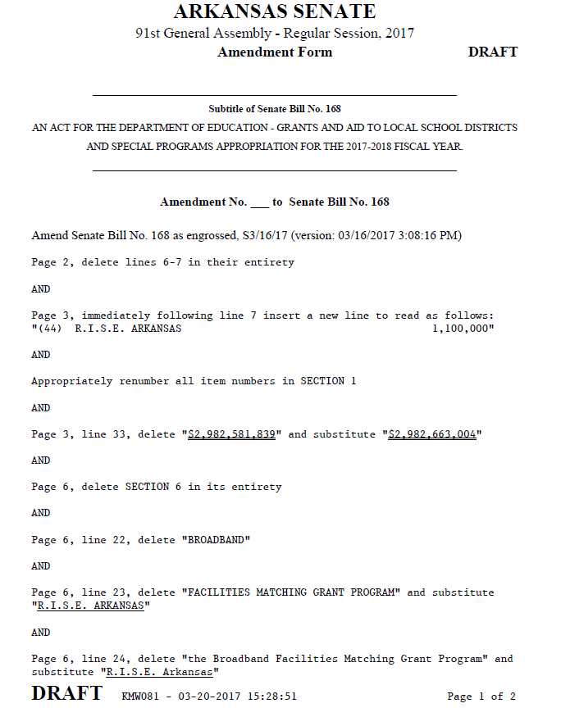

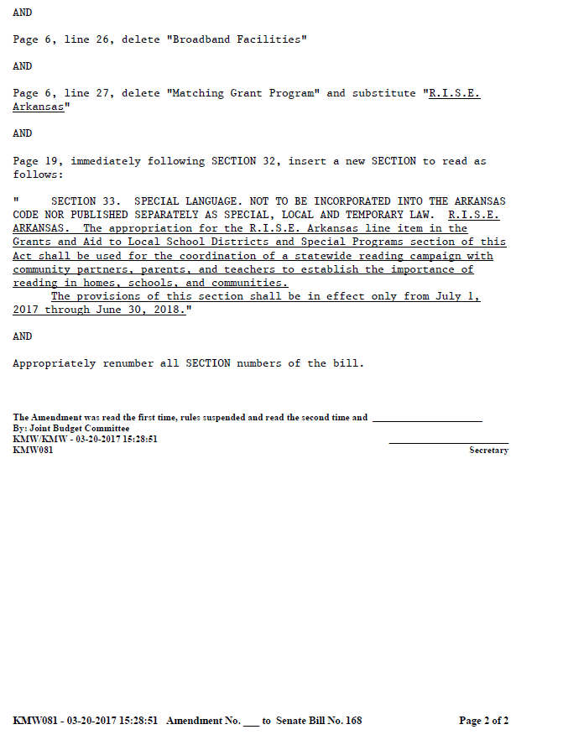
ATTACHMENT 2

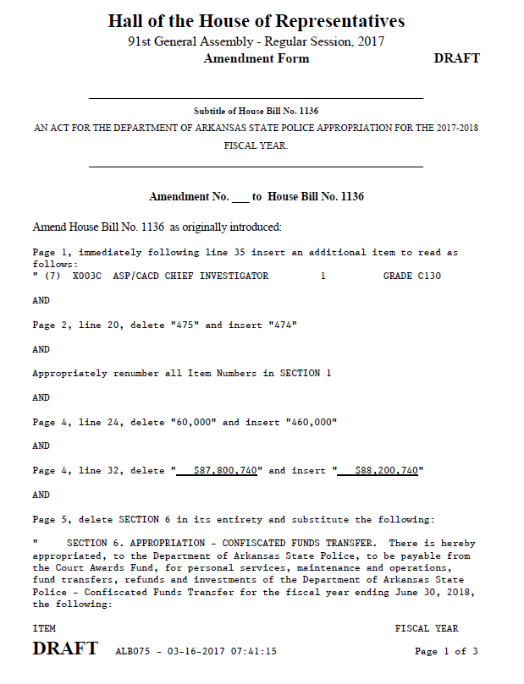

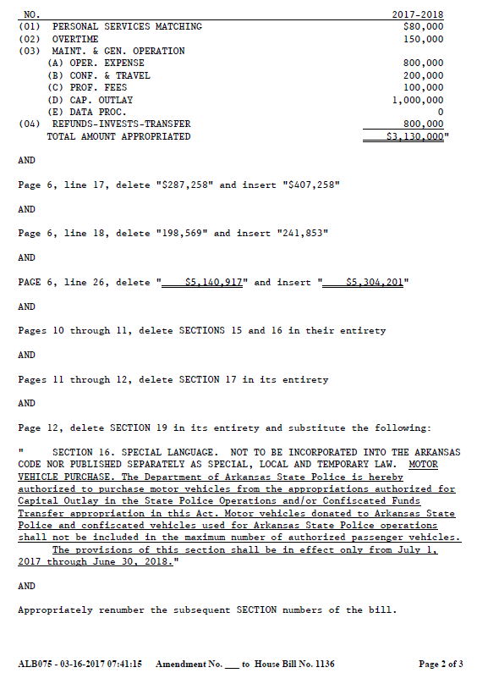

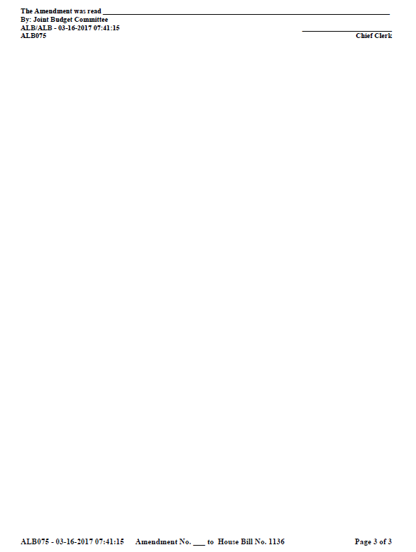

ATTACHMENT 3
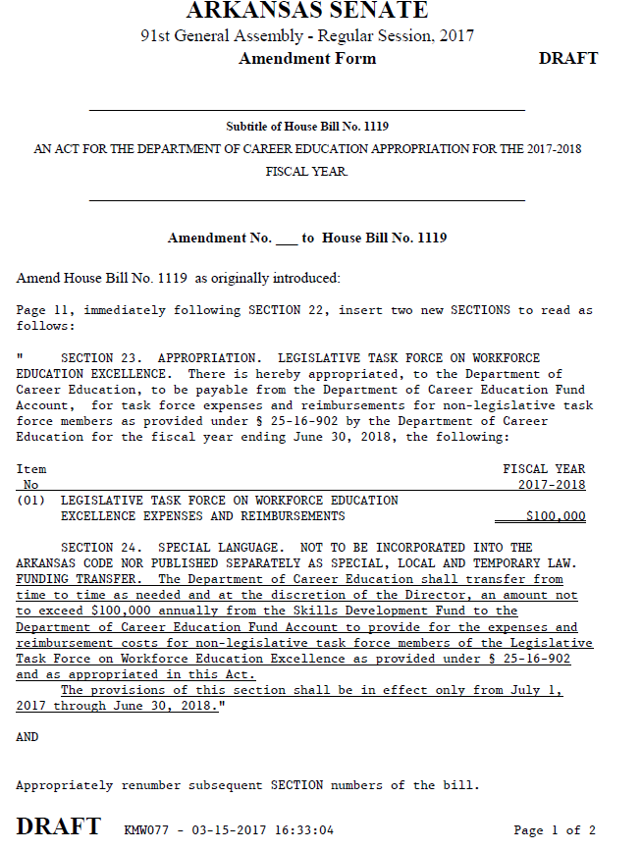

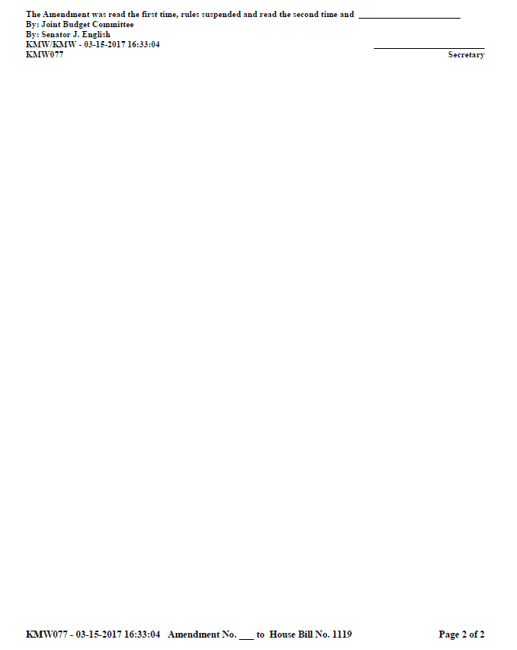

ATTACHMENT 4
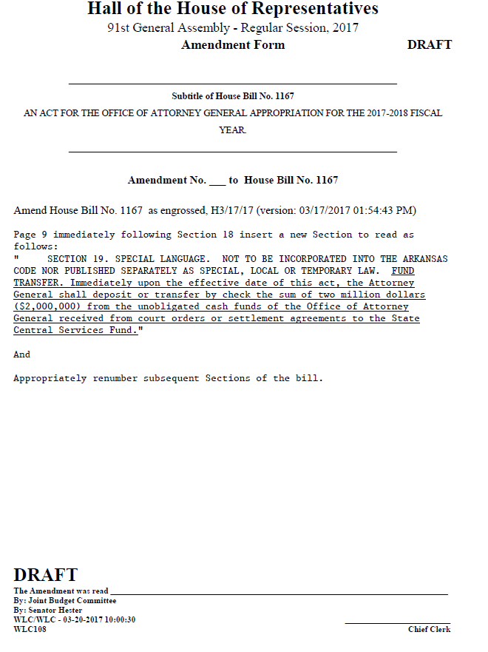

ATTACHMENT 5
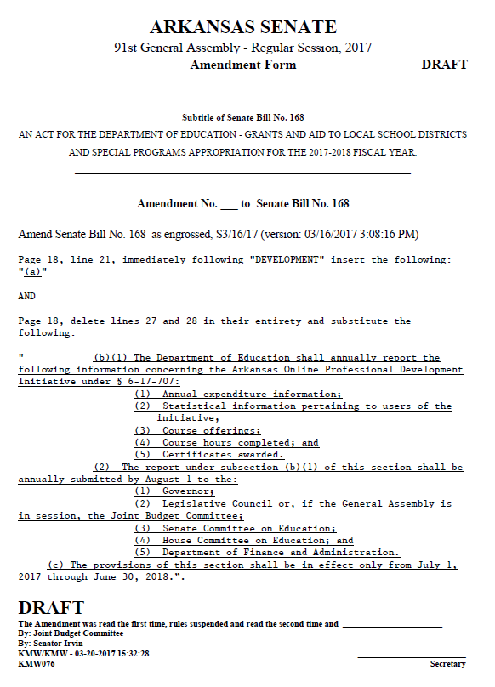

ATTACHMENT 6